**DDL Scripts**

Name: Joshua Youens

Student ID: 2332364

This is a document for 5CS024: Collaborative Development. This will contain, all the DDL scripts for the database tables used in the ERD and other tables used in the web application.

Table name: Signup

|  |  |  |
| --- | --- | --- |
| **Field Name** | **Data Type** | **Constraints** |
| ID | int | Primary Key, Auto increment |
| Name | Varchar(128) | Max 128, Not Null |
| Email | Varchar(255) | Max 255, Not Null |
| Password_hash | Varchar(255) | Max 255, Not Null |
| Event | int | Foreign key, Null |

DDL Script Screenshot:

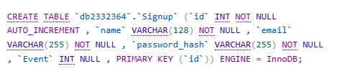

----------------------------------------------------------------------------------------------------------------

Table name: Signup_staff

|  |  |  |
| --- | --- | --- |
| **Field Name** | **Data Type** | **Constraints** |
| ID | int | Primary Key, Auto increment |
| Name | Varchar(128) | Max 128, Not Null |
| Email | Varchar(255) | Max 255, Not Null |
| Password_hash | Varchar(255) | Max 255, Not Null |
| Event | int | Foreign key, Null |

DDL Script Screenshot:

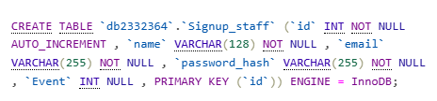

----------------------------------------------------------------------------------------------------------------

Table name: App_events

|  |  |  |
| --- | --- | --- |
| **Field Name** | **Data Type** | **Constraints** |
| Event_ID | int | Primary Key, Auto increment |
| Event | Varchar(50) | Max 50 , Not Null |
| Course | Varchar(100) | Max 100 , Not Null |
| Time | int | Max 50 , Not Null |
| Information | Varchar(2000) | Max 2000, not null |
| Room_Number | Text(10) | Max 10, not null |

DDL Script Screenshot:

----------------------------------------------------------------------------------------------------------------

Table name: tips_wlv

|  |  |  |
| --- | --- | --- |
| **Field Name** | **Data Type** | **Constraints** |
| tips_ID | int | Primary Key, Auto increment |
| information | Varchar(100) | Max 100 , Not Null |

DDL Script Screenshot:

----------------------------------------------------------------------------------------------------------------

Table name: Alumni_wlv

|  |  |  |
| --- | --- | --- |
| **Field Name** | **Data Type** | **Constraints** |
| Name | text | Text only, not null |
| Year_Graduated | int | Not Null |
| Degree | text | Text only, Not Null |

DDL Script Screenshot:

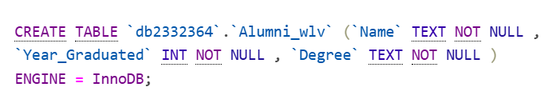

----------------------------------------------------------------------------------------------------------------

Table name: rating

|  |  |  |
| --- | --- | --- |
| **Field Name** | **Data Type** | **Constraints** |
| Num_rate | int |  |
| Comment1 | Text(255) | Max 255, Not Null |
| Comment2 | Text(255) | Max 255, Not Null |

DDL Script Screenshot:

